**John Von Neumann: What have we learned from him?**

Alyssa Ramos-Stonecipher

Spring 2026 - Computer Logic

SDEV120 - Computer Logic

Prof. Chet Cunningham

January 28, 2025

# Who is John Von Neumann?

# John (Janos) Von Neumann was a Hungarian-American mathematician, physicist, computer scientist, and engineer. In 1945, he introduced the Von Neumann architecture, which greatly advanced early computer development. This design allowed for more efficient use of a single machine, decreasing the time for various tasks. Unlike earlier systems that needed rewiring for different calculations, this architecture removed that requirement. It is still used today in everyday computing.

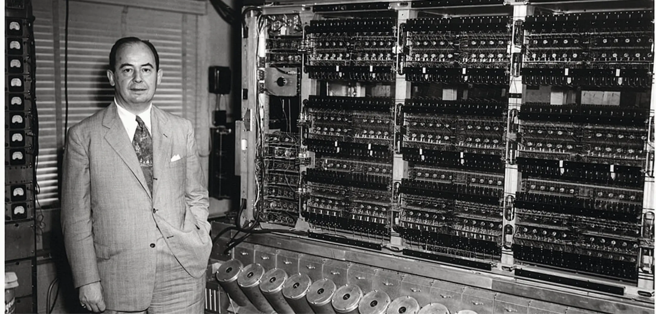

Figure 1. John Von Neumann circa 1952. (*John Von Neumann, the Designer of Computer Architecture*, 2024)

## What does the Architecture consist of?

The Von Neumann architecture consists of the CPU, Memory, and I/O Devices. (*Components of Von Neumann Architecture*, 2025) as well as the movement through a single bus.

The first component I will cover is the CPU. The CPU is a mechanical part within a computer, functioning as an electronic circuit. “The CPU (Central Processing Unit) is the main part of a computer that controls how it works.” (Components of Von Neumann Architecture, 2025) It processes data, instructions, information, and results. Inside the CPU are various components such as the Control Unit, Logic Unit, and registers.

The Memory Unit works closely with the CPU. These two communicate through a ‘Bus’. Typically, in Von Neumann architecture, there is a single bus connecting them. The Memory Unit is made up of RAM, often called primary or main memory. (Von Neumann Architecture, n.d.)

Finally, there are the I/O Devices, including a keyboard and mouse for input, and a monitor for output. These devices enable us to interact with the computer, essentially speaking and listening to it. To illustrate this, I’ve included a diagram below showing how each component communicates with the others.

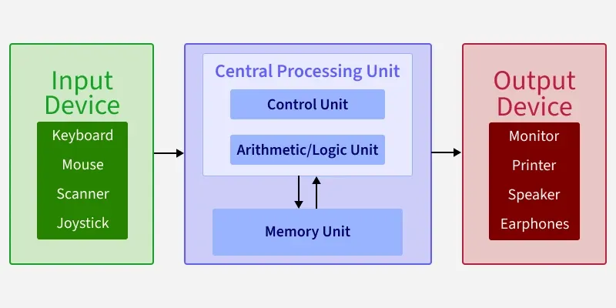

Figure 2. Visual of the Von Neumann Architecure (*Components of Von Neumann Architecture*, 2025)

### What significance does this have to modern day computing?

The Von Neumann architecture is crucial because it established the basic design model that enabled modern computing to be scalable, adaptable, and programmable. Before this architecture, computers were either exclusively wired for a single task or were impossible to reprogram. Soon after its development, components capable of internal reprogramming appeared. Although these components are still in use today, they have significantly advanced.

The CPU has become multi-core and multi-threaded, with billions of transistors on a single chip. Memory capacity has increased, and secondary storage options such as SSDs and cloud storage have been introduced. The bus system has also evolved; previously, the Von Neumann bottleneck limited data flow, as information could only pass through one line at a time. Today, multiple high-speed buses enable faster, more efficient data transfer. Overall, John Von Neumann made a major leap forward in computing science. Much of what we consider normal today wouldn't be possible without his contributions.

**References**

*Components of Von Neumann Architecture*. (2025, September 20). GeeksforGeeks. Retrieved January 28, 2026, from https://www.geeksforgeeks.org/computer-organization-architecture/computer-organization-von-neumann-architecture/

*Dive Into Systems*. (n.d.). Dive Into Systems. Retrieved January 28, 2026, from https://diveintosystems.org/book/C5-Arch/von.html

*John von Neumann, the Designer of Computer Architecture*. (2024, July 2). IT Museum DataArt. Retrieved January 28, 2026, from https://museum.dataart.com/short-stories/john-von-neumann

*Von Neumann Architecture*. (n.d.). Computer Science GCSE GURU. Retrieved January 28, 2026, from https://www.computerscience.gcse.guru/theory/von-neumann-architecture